CONSTRUCTION COST DATA WORKBOOK

Neil Sinclair, Philip Artin and Stewart Mulford
DMS International

Conference on the International Comparison Program
World Bank
Washington, D.C., March 11-14, 2002
Collection of construction cost data

Workbook modified bills of quantity format

Introduction
DMS International, Inc. was requested to assist the World Bank with creating a method of collecting construction cost data from member countries throughout the world to assist with economic studies. The task of data collection is a difficult procedure and can be prone to wide variations. Based upon our experience as construction cost consultants, estimators and quantity surveyors we chose to develop a data collection method based upon a workbook format. Our workbook defines construction line items and quantities for relativity simple building types. In fact, four building types have been chosen:
- Residential house
- Warehouse
- Road
- Office building

The workbooks would be sent to member countries to be completed by local contractors, estimators or quantity surveyors. When completed the data would be collected and analyzed by the World Bank as part of its overall economic study.
Before we explain further about our workbook format and design, reference must be made to previous studies and methods of construction cost data collection. One comprehensive review of past practices has been completed by Dubner and McKenzie¹. This detailed study compares various methods and documents the advantages and disadvantages of each method. The method that provides the best opportunity for data collection was noted as the Bills of Quantity (BOQ) method. This method appears to have advantages over the other methods but yet even with the BOQ method some potential pitfalls exist.
A BOQ is basically a listing by trade of certain construction components that make up the total project. The project may be an office building or a warehouse. The BOQ documents quantities for each element of the building type such as cubic meters of concrete foundations or square meters of roofing material. BOQ’s are used frequently to assist in developing tenders or bids for projects throughout the world. The BOQ may be provided by an independent party or in house by the bidding contractor. Once the quantity of concrete footing is known a unit price to cover for material, labor and equipment is applied to develop the cost of each line item or component. The total project is basically a summation of all the individual line items. Various levels of sophistication in terms of measurement detail and description exist with BOQ’s but the same principals apply. The paper prepared by Dubner and McKenzie¹, suggests that the BOQ method offers the best opportunity for data collection, though they suggest issues that must be dealt with to allow data collection to prove more successful than in the past. The issues highlighted were:
- Interpretation of specifications
- Expertise to price BOQ
- Applicability of specifications to local design criteria
- Over sophistication and requirement to price detail project work break downs
Silke Stapel² also highlights various issues with cost data collection along the similar lines as Dubner and McKenzie¹. Stapel ² is part of Eurostat, an organization that has actually performed data collection on behalf of EU member states. Part of the Eurostat data collection used detailed Bills of Quantities.
Stapel ² along similar lines as Dubner and McKenzie¹ noted some issues such as:
- Data collection was expensive in terms of resources required to implement system
- Bills of Quantities adopted by Eurostat appear too cumbersome in terms of level of detail and sophistication

It would appear that the Eurostat data applies to advanced Countries in terms of construction management and professional expertise. The Eurostat surveys collect prices for about 15 Bills of Quantities. The typical Bills of Quantities could have up to 1000 line items.

A Modified Approach
In our approach, we have attempted to incorporate improvements into the workbook approach such as:

- Provide a consistent quantity of materials and line items to price
- Line items are simple and comprise basic building materials common to most countries (e.g. cubic meters of footings)
- Quantities and line items reflect approximate quantities according to a trade break down. The trade breakdown adopted reflects American Institute of Construction Specifiers, 16 divisions trade format. The trade format reflects a traditional worldwide understanding of how a project is built and categorized by specialty.
- Projects chosen offer little complexity that would impact construction means and methods. The projects provide materials used in nearly all construction projects such as concrete, steel, wood, and plumbing piping, irrespective of what country or location this project may be located.
- Projects chosen are easy to understand allowing the estimator to grasp the overall project massing and configuration. Workbooks contain outline drawings.
- Project content provides for the basic construction products used extensively in any project. This limits the specification issues that provide inconsistency among different Countries. Basic materials such as concrete are relatively similar from Country to Country.
- Designs chosen offer little complexity for pricing purposes. If the material or component is not widely used then an opportunity exists for each individual estimator to customize pricing based upon best local practices. This will occur to some limited extent from Country to Country but as long as a substitute of equal is priced then this variable factor will be minimized.
- Project site work and substructures are quantified therefore minimizing project cost variances by building on a flat site as compared to a steeply sloping site.
- Outline specifications provided show basic specifications that allow the estimator to use more locally compliant products.

It’s accepted that the workbook could and should only be completed by someone experienced in estimating construction projects. To have the workbook completed by inexperienced estimators would only add to the potential for erroneous data. By keeping the models and format basic by design the chances of greater overall success will exist. A person experienced in estimating construction costs should have little problem working through the workbook and creating a complete price for each project.
The probability of success with the collection of cost data must be viewed in two parts. Part one being the design and format of the actual workbook and part two being the expertise of the person completing the workbook exercise. It would be rather foolish to issue the workbook to an individual unqualified in pricing BOQ or creating cost estimates. The success of the workbook format will only exist if the data is priced by qualified individuals. Even with qualified individuals variations will occur. Sinclair ³ found that even qualified estimators would not produce equal estimates given the same information from which to create an estimate. The balance of this paper identifies this “estimating” problem to allow the perceived problems of collecting data via workbooks to be put totally into perspective. The author of this paper agrues that perfection of data collection can only be a goal but can never be achieved.

The Estimating Problem

How does an estimator estimate the cost of a construction project? For those reader’s not familiar with cost estimating, the process involved is complex. Learning about cost estimating will help non-cost-estimators understand what is involved and what limitations exist when reviewing cost data generated by cost estimators.
Fig. 1.1 The estimating objective: to hit the target.

Figure 1.1 illustrates subjective estimates attempting to hit the target, which is the actual cost. The subjective value chosen by each estimator was considered to represent the resources required by each firm to complete an example office-building project. We can see that the estimates are all scattered around the target of actual cost. Hitting the target is not a common occurrence and is an inbuilt problem of estimating.
Briefly, let us consider an estimator pricing a brickwork item.
What are the difficulties presented? They are as follows:
1. Choice of work method.
2. Output of crew (given the firm’s unique efficiency).
3. Cost of labor
4. Cost of material and selection of an appropriate wastage allowance.
5. Addition of overheads and profit

Problem 1 - Choice of work Method
There may be many or only a few work methods available. For instance, should the estimator assume a three-man or a four-man crew, composed of two or three bricklayer with either one or two laborers? Will there be central mortar mixing or individual mixers for each crew? How will the brickwork be constructed? Will trestles or proper standing scaffolding be used? Where will work commence from? What restrictions will the other trades impose on the masonry work?
All possibilities must be investigated, and the most economical possibility should be chosen.

Problem 2- Output of crew
The output chosen will be based on past performance, since the estimator will assume that this performance will be repeated in the future. As will be explained later, recording and properly documenting job site performance is helpful to the estimator when he or she considers future projects. Manipulation of these historical data may occur; for example, decreasing output to allow for restricted working condition. Whatever manipulation occurs, the estimator is faced with the difficulty of trying to assess what output will be achieved.

Problem 3- Cost of labor
How much will the contractor be required to pay for labor? The estimator must predict this cost. The labor cost will vary depending on job location, availability of skilled labor, contract wage regulations, union or open shop labor requirements, general market conditions, and so on.

Problem 4- Cost of Material
This can be predicted with a fair degree of accuracy if the material in question is in ready supply and is frequently purchased. The quantity of material required must be accurately measured from the drawing and is not dependent on the crew performance or work method adopted. Although the estimator must not only consider the finished in -place quantity of material, but also must allow for a wastage factor, this factor can vary dramatically and is highly dependent on the performance and work procedures adopted by the crew.

Problem 5 - Addition for overheads and profit
This amount will depend on company policy, market condition, and many other variables that will be discussed later. It is, as you can imagine, very important to incorporate overhead and profit into the final estimate.

Problems 1-5 have been presented simply, but you can begin to imagine their complexity.
An estimator has to posses the skill and expertise to assemble the known facts and rationally solve the estimating equation. How this is done is best explained by reference to the decision tree diagram shown in figure 1.2.

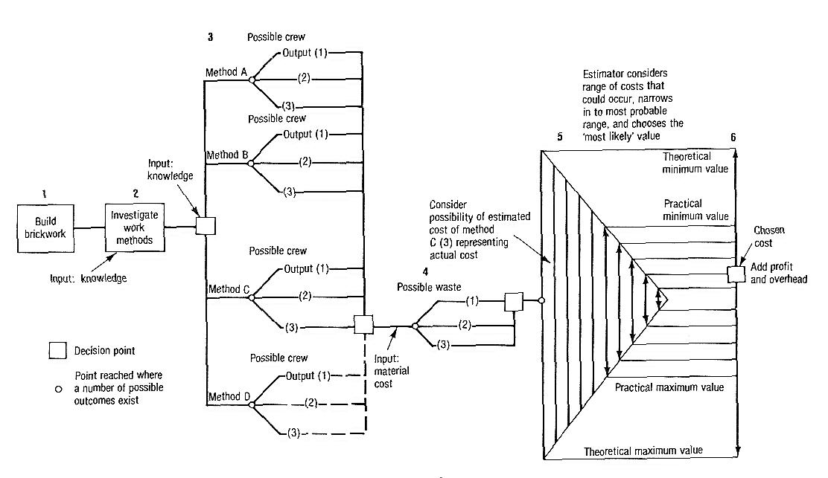
Fig. 1.2 Hypothetical decision tree diagram.

Figure 1.3 amplifies stages 5 and 6, here the estimator selects a range of most likely values and, after a process of fine tuning and “weighing up” of the situation, the estimator modifies his or her initial crude selection and finally selects a value that he or she considers to be ‘most likely.”
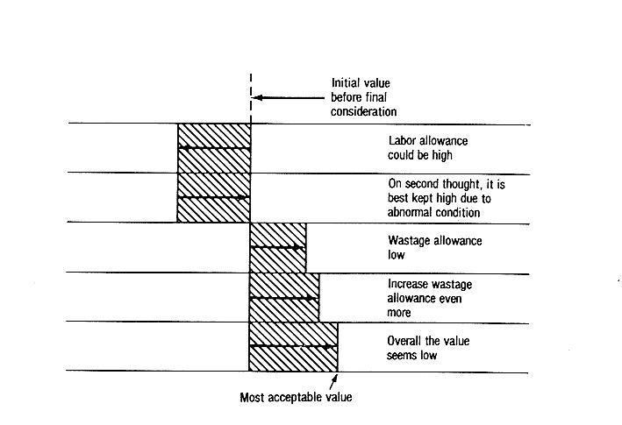
Fig. 1.3 Fine tuning an estimate.

The thought process previously described and shown in fig.1.2 and 1.3 applies to our hypothetical brickwork example, but generally indicates how and estimator arrives at a solution for each separate item of the cost estimate. A total cost estimate consists of numerous line items and specific sections relating to various trades and specialists subcontractors. This thought process will usually be repeated on numerous occasions during the compilation of one single estimate or bills of quantity.

Location
Since a construction project’s location affects the final cost, an estimator must understand what particular locational factors will be encountered and what considerations should be taken into account when formulating the estimate. Estimators are aware that costs in Boston are different that costs in Miami, but not everyone is aware that the locational variation within the Boston area or within the Miami area also influence construction costs. For example, the project location may be a restricted city center infill site or a remote country site, each having its own particular difficulties that the contractor must overcome.

Various locational difficulties are described:
1. Remoteness
2. Confined sites
3. Labor availability
4. Weather
5. Design considerations (related to location).
6. Vandalism and site security

Remoteness
A remote construction site, for example, a project site located high in the Blue Ridge Mountains of Virginia, poses a contracting organization with a difficult set of problems to cope with.

Communication Problems
If adequate communications such as telephone are not available, then a radio or cellular-type installation is required. A telephone is a requisite to any construction project: lack of communication during the construction process can result in major, costly errors. In addition, because the project location is further away from the head office, additional long-distance telephone charges will be incurred.

Transportation Problems
All material and labor must be transported to the building site. If the transport route is poor (if, indeed, any route exists at all), then delays in material deliveries may occur; large vehicles may damage narrow bridges or other items of property, whose replacements costs must be borne by the contractor.
It may be necessary for the contractor to widen the existing route or construct a bridge to allow material trailers access into the job site. The route that is proposed should be studied carefully by the estimator. Existing capacity of existing bridges on route should be established to verify if equipment loads can be accommodated of if the bridge needs to be strengthened by the contractor. Finally, the cost of hauling items of equipment to the job site increases as the distance increases. Given these considerations, the requirement for management to make the correct equipment selections becomes very important.

Increased Material Cost
Increased material cost is primarily due to increased transport charges such as when distance for haulage from the depot to a remote job site is longer than the haulage associated with other construction projects the estimator has previously worked on. Avery⁴ found that if the material was fragile or hazardous, then transport costs fluctuated widely depending on distance. He also discovered that the bulk materials with low initial cost, such as sand and gravel, tend to be the most adversely affected by distance and difficult transport conditions. Ferry crossing or bridges with tolls increase the basic cost of materials.

Power and Water
Power and water are a necessity for building construction. Water is needed for materials such as concrete, for cleaning the building, and for many other uses. Salt water is not acceptable in most specifications for concrete or mortar mixing, so remote projects without a convenient domestic water supply, even if the site has access to thousands of gallon of seawater; require water to be trucked to the job site. The cost of water depends on the hauling costs. In some instances wells can be dug to pump water to the surface; of course, the costs involved must be considered in the estimate.
If no power source is available, then power must be provided by generators.

Confined Sites
The problems associated with confined sites generally take the form of congestion resulting in restricted working areas resulting in low productivity from labor and equipment. These difficulties are generally associated with downtown sites, but this need not always be the case.
In extreme cases, congestion can limit the choice of work methods, types of equipment used, and size of crew to be employed. Careful investigation of the problems likely to be associated with each particular site will allow a realistic assessment of factors such as productivity to be made. Project startup requires a careful utilization of resources in order to provide production outputs that maximize profits. Confined sites create logistical problems. Material movement should be minimized: each time an item of material is moved, its cost to install in place increases. When materials are delivered to a confined site, the material should be used immediately. If this is not possible, a storage area should be available to receive the material, or, if possible, the material should be offloaded directly at its intended utilization point.
The estimator needs to consider the unique logistical problems associated with each job site. These problems, including restricted access, restricted material lay down area, restricted equipment storage areas, and restricted location for site trailers, affect the type of equipment that can be used, the effective management of the job, the worker productivity, and the amount of labor involved in handling material. Since confined sites nearly always pose logistical problems, the unit prices used by the estimator must account for the increased costs.

Labor Availability
Each location has varying amount of available skilled and unskilled labor, depending on the condition of the local economy. If labor of any kind is not available locally (as may be the case in remote areas), then labor must be imported from other location. In order to move labor from one area to another, a financial incentive is usually required. The magnitude of this incentive will vary depending on the state of the labor market. If labor is imported, accommodations may have to be provided. Labor camps comprising full time kitchen staff, dormitories, leisure facilities, etc., have been set up on major construction project to house the contractor’s labor force. The leisure facilities keep the labor force relaxed and occupied during any rest periods. Living and working on a remote construction site can be very demoralizing, after a while, and by keeping the morale level high, labor turnover is reduced. Generally, the cost of importing labor will follow the laws of supply and demand.

Weather
Since the building process is highly weather dependent, extreme conditions can greatly affect building costs. These extreme weather conditions include large amount of rain or snow, occurrences of ice and frost, and high humidity and heat. Their effects on cost include the following situation. Concrete pours in temperatures below 40 degrees Fahrenheit require special precaution. With cold weather concreting, the cost of admixtures, insulation the formwork, removing ice from formwork, and protecting the freshly placed concrete from dropping below the specified temperatures must be taken in to account by the estimator. Not only does cold weather affect concrete, but hot weather concreting has its associated problems as well. During periods when the temperature exceeds 80 degrees Fahrenheit, special precautions are required to reduce and maintain the concrete below this temperature. For example, ingredients such as the water may be cooled or chopped ice can be utilized. Another alternative is to use liquid nitrogen to cool the concrete. Admixtures and low heat cement can be used to control the set and hardening times of the concrete to achieve the design strength and quality. All these precautions and procedures increase the cost of pouring, placing, and curing concrete.
Exposed sites may have problems associated with high winds, which affect crane and hoisting operations, and the contractor’s dust control program. Additional temporary bracing to partly completed structures may be required to prevent a collapse due to high wind gusts. In areas where hurricanes occur, the estimator should consider the cost of temporary measures required to prevent damage to a structure before, during, and after a hurricane. It would be prudent to allow for the costs involved in bracing, tieing down structures providing sand banks, garaging equipment, and storing particular materials such as doors and windows off the job site, unless safe, dry, and secure storage exists on the project.
Labor productivity is also associated with the weather. During poor weather when it is cold, damp, and windy, the morale of workers exposed to adverse elements, drops, which in turn results in a decline of productivity. During days when it may be impossible to work, such as during a torrential rain, the productivity is zero.

Design Considerations (related to location)
The location of a project has certain aspects that must be considered by a designer. For example, in historic Frederick, Maryland, all designs must harmonize with the existing historical buildings. Planning committees may dictate the material selections and configurations that designers must abide by to suit certain local conditions.
These design considerations can create estimating problems in historic districts. The estimator must know if the materials specified are, in fact, locally available of if local labor exists to carry out complicated historical work, such as ornate plaster work; if not, a specialist will be required. Traditional building techniques tended to be labor intensive. If the same techniques must be repeated, then the estimator must be familiar with the procedures involved. If workers are required to use traditional, building methods with which they are unfamiliar, then a learning curve cost needs to be built into any unit price.
The local climate also dictates the designer’s choices in mechanical and electrical systems and in the choice of materials and design of the building envelope. Material resources will fluctuate from location to location throughout the country, and the designer must investigate what materials are locally and economically available.
Finally, each locality tends to have its own construction trade practices, and the estimator should be familiar with them.

Vandalism and Site Security
Site integrity is an important problem in urban areas. Protective measures can be expensive, for example, when 24-hour guard service and perimeter enclosures, are required. The level of security will depend on the risk to the project from the surrounding neighborhood. The local police should be consulted.

Variability of Estimates
The following are where cost variances between one estimate and another can occur:
1. Quantity take off.
2. Material Costs.
3. Labor Costs.
4. Labor productivity forecasts.
5. Work Methods.
6. Construction equipment costs.
7. Indirect Job costs.
8. Subcontractor quotations.
9. Quotations from material suppliers.
10. Unknown site conditions.
11. Locational Factors.
12. Cost associated with the time element of the construction project and escalation costs.
13. Staging and project start up costs.
14. Overheads.
15. Profit element.
16. Contingency and risk allocation.
17. Errors in estimate formulation.
18. Basis of information used to formulate estimate.
19. Market forces.

Wendes⁵, commenting on the estimating ability of estimators lists the following points concerning their performance when estimating projects:

1. Reasonably correct with shop labor if everything is standard.
2. Good with raw material and equipment pricing.
3. “Okay” with subcontractor quotes if they are familiar with the work; “bomb out” if they are unfamiliar.
4. At the “high school level” with their quantity take offs.
5. Unsatisfactory with special items.
6. Poor with field labor.
7. Fail with overhead markups.
8. Coverage of profit is in the realm of wishful thinking.

Variances between estimates and actual costs do occur. The estimator, unfortunately, always appears to be incorrect, since an estimate is an “estimate”, which is a forecast of the anticipated future cost. Many forces can, in reality, cause the actual cost to vary from the estimated cost. It sometimes appears to owners and management that, when the estimate does not equal the actual costs, a mistake has been made. Because it is an estimate, it should always be expected that the actual cost will vary somewhat from the estimated cost. It is the job of the estimator to minimize the extent of variance between estimate and actual cost. Any data collection system must be able to recognize that variances exist.

Explanation of Variances - Why Do They Occur ?
As previously discussed, the author believes that there are 19 major areas where differences between cost estimates can exist. When compiling the cost estimate, each of the 19 categories has to be dealt with by the estimator. In dealing with each category, the estimator has to make several assessments, such as what subcontractor price for drywall should be used in the cost estimate or what labor productivity shall be used for the carpenters installing intricate millwork. The total cost estimate is made up of numerous smaller cost estimates for each activity required to complete the overall project. The estimating equation is therefore composed of a series of calculations, the estimator has to assess and propose a monetary solution. The total cost estimate is the total of all the minor monetary solutions.

Each assessment the estimator performs is based on:
- Previously recorded data (historical data)
- The estimators own past experience.
- Previous experience of others.
- Hunches.
The final assessment is subjective. The estimator will decide what productivity to allow, or what dollar allowance or unit price to use. Even though the estimator has consulted with subcontractors, suppliers, site superintendents, project managers, and others, when compiling his or her estimate, it is the estimator who will decide what value will be used in the estimate. This subjective act is the main reason why estimates vary. If you give identical drawings and specifications to 100 estimators, you will get 100 different cost estimates.
Figure 1.4 indicates the factors influencing variance in an estimate.
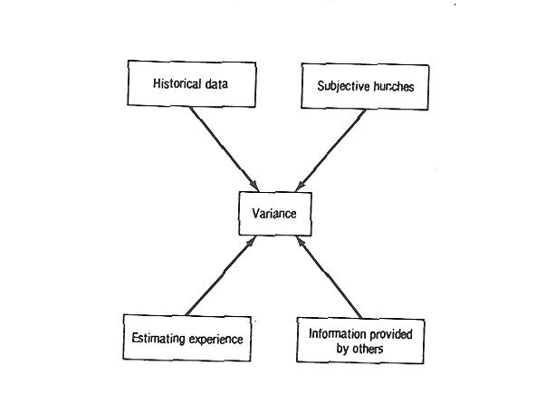
Fig. 1.4 Basic reasons for variances being introduced into cost estimates – the subjective assessment.

Historical Data

Historical Data is used frequently by estimators when compiling cost estimates, with their attendant advantages and disadvantages. There are some rules to be followed, which are extremely important:

- Always understand the source of the historical data.
- Always understand what the historical data represent
- Always understand what time period the historical data reflect.
- Always understand fully how to update and project the historical data to the present time.
- Always understand how to manipulate the data to represent your particular project, since no
- Two projects are the same.
- Always be wary of working with historical data that you are not familiar with.

Various sources of historical data are available, such as published price books, cost information publication services, trade journals, and, most important, cost feedback from actual projects that the estimators firm has been involved with and therefore most knowledgeable of.
Actual cost feedback is the best information to use if it were recorded and documented properly. The feedback cycle (see Fig 1.5) is of critical importance. In order for estimating to be effective, feedback from the job site must occur. Actual costs should be compared with estimated costs to inform the estimator of his or her performance during the estimating phase. Unfortunately, the feedback process is not carried out effectively within the industry. To quote the Business Round Table Report on modern management systems⁷: “Even within companies, a feedback of actual costs is not consistently used to review and adjust the basis for estimating future projects.”

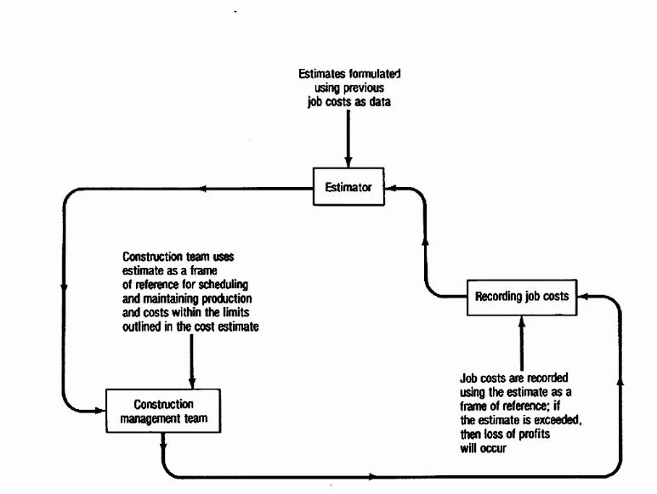
Fig. 1.5 Company cost feedback cycle.

Sound estimates are produced from a combination of experience and recorded cost data of similar work previously performed. The cost data, if proper feedback procedures have been adopted, will have been refined over time to reflect accurate costs for performing certain operations. The estimator can use these data to formulate estimates accurately for future work. If the data to formulate are incorrectly used or formulated, then mistakes will undoubtedly occur.

Accuracy Versus Economy
Estimating involves the assessment of probabilities and risks making complete accuracy impossible. However within the limits of achievable accuracy, it can be stated that the greater the accuracy, the higher the cost of achieving that accuracy. There is usually a point beyond which the cost in increasing and estimate’s accuracy is greater than the benefit to be gained.

Figure 1.6 indicates the accuracy versus economy dilemma. As more of the estimator’s time and effort are devoted to the preparation of the cost estimate, a point is reached where obtaining the utmost accuracy is not economical. As we have discussed 100% accuracy is impossible.

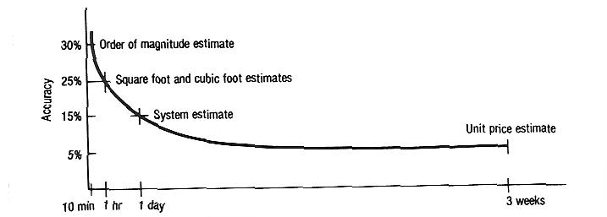

Fig. 1.6 Estimating time required for a $2,000,000 building (© R.S. Means, Inc., 100 Construction Plaza, Kingston, MA, reproduced from Mechanical and Electrical Estimating Workbook.)

Figure 1.7 indicates the general accuracy that is expected by employing varying amounts of estimating manpower.
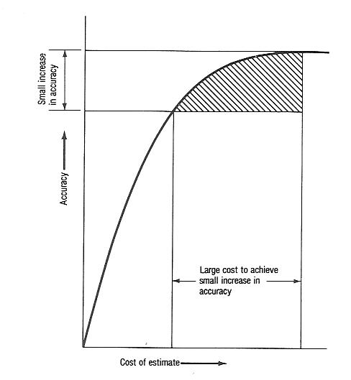

Fig. 1.7 Estimate accuracy versus costs of estimate.

The Pareto Distribution in Estimates
The estimator will price (or at least consider) each item he has discovered, such as cubic quantity of concrete footings, walls or slabs. These items may be in the form of a detailed quantity take off or some other form sufficiently detailed to enable confident estimating to occur.
Each of the items discovered by the estimator has a cost importance that varies in magnitude. Some items are of more cost importance than others, since they form a larger percentage of the total cost than the minor items do. The Pareto effect is seen to occur, that is, a small proportion of the items account for a very large proportion of the cost. Investigation into the cost structure of items in Bills of Quantities by Brown ⁸ has shown that, typically, 20% of the items priced contained at least 80% of the total cost. (See Fig 1.8)
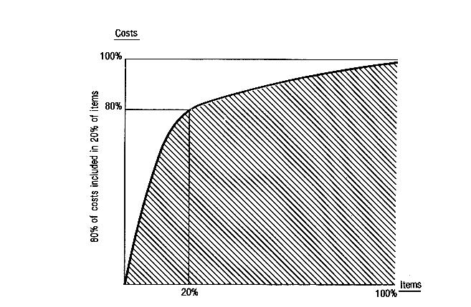

Fig. 1.8 Pareto principle applied to estimating. (Reprinted from R. Brown, Investigating into the Feasibility of Applying the Pareto Principle to SMM Bills of Quantities of Cost Planning, Project Report, Loughborough University, UK.)
The Pareto effect can be used to great advantage by applying strict control over the major items; the chance of major errors and discrepancies occurring is therefore reduced. Owing to the time constraints involved with preparing a competitive bid, the Pareto effect should be taken advantage of. Estimators should be quick to recognize what the major items of cost importance are and devote attention to these items. When faced with abnormal conditions, the search for the critical items of cost may take longer, but the Pareto principle should still apply. Both Dubner and McKenzie¹ and Stapel² recognized this aspect with current BOQ methods. We have attempted to provide concise and specific line items in the modified work book approach to accomplish major resource savings at very little, if any, expense of quality.
It has been noted that wide variances do occur between estimates. If 100 estimators prepared an estimate for the same project using identical drawings and specifications, then 100 different estimates would be submitted. Remarkably, though, the bottom line of the estimates would be within an acceptable range of some +/- 10% of each other. This is often the case when contractors submit bids for projects. The bids submitted by the majority of bidders are quite often very close to each other. Though, when examination of the bidders estimates occur, the cost difference between each of the trades differ greatly (up to 25%) and when examination of the cost to complete each activity within each of the trades occurs, the cost differences between each bidders numbers can be as much as 50%. The degree of difference between estimates will therefore differ depending on whether you are examining the bottom lines, the trade amounts, or the cost of activities within each trade. Greater variances within estimates occur when uncertainty exists, such as in excavation work. Our workbook format excludes site work and varying site related features thus eliminating an area of major uncertainty.

Conclusions
The modified workbook approach attempts to simplify yet increase the quality of information received through cost data collection methods. It’s agreed by both Stapel² and Dubner and McKenzie¹ that the preferred tool is the Bills of Quantity Method. Our workbook format is based upon abbreviated Bills of Quantities that provide a consistent set of line items that can be priced without difficulty by a local estimator qualified in construction cost estimating. The line items proposed can provide information on various levels such as:
- Cost per building type
- Cost of each trade
- Cost of individual line items such as concrete footings

These levels of information can be used to formulate “basket” of data that could be analyzed even further. Merging of the Basket of Goods Collection Method and the Bills of Quantity Method is possible given the simplified format of the modified workbook approach.
References:

¹ Dubner and McKenzie, Australian Bureau of Statistics paper submitted to international conference on ICP, World Bank, Washington, DC (11-13 March 2002).
- Stapel Silke, Eurostat, Paper submitted to international conference on ICP World Bank, Washington, DC (11-13 March 2002).
- D. Neil Sinclair, Estimating for Abnormal Conditions, Industrial Press, Inc., New York, New York, 1989
- D.W. Avery, “Problems of Locality in Construction Cost Forecasting and Control,” in Building Cost Techniques, edited by P.F. Brandon, E.F.N. Spon Ltd., New York, New York, 1982.
⁵ H.C. Wendes, The Eight Facets of the Estimating Diamond, Heating/Piping/Air Conditioning, October 1976, pp. 51-56.
⁷ The Business Roundtable, Modern Management Systems, The Business Roundtable, New York, New York, Report A-6, November 1982.
⁸ R. Brown, Investigating into the Feasibility of Applying the Pareto Principle to SMM Bills of Quantities and Cost of Planning, Project Report, Loughborough University, UK.

At the end of the 19th century an Italian economist, Vilfredo Pareto, developed a curve known as “Pareto’s Law of Distribution.”

